**TRUSTED SELLERS**

**A Project Work**

*Submitted in the partial fulfilment for the award of the degree of*

**BACHELOR OF ENGINEERING**

**IN**

**COMPUTER SCIENCE AND ENGINEERING, BIG DATA AND ANALYTICS-IBM**

**Submitted by:**

**RICHIE BANSAL**

**17BCS3932**

**Under the Supervision of:**

**VISHALI AGGARWAL**



**APEX INSITUTE OF TECHNOLOGY**

**CHANDIGARH UNIVERSITY, GHARUAN, MOHALI - 140413, PUNJAB**

**2017-2021**

**DECLARATION**

I, **‘RICHIE BANSAL**, student of **‘Bachelor of Engineering in COMPUTER SCIENCE AND ENGINEERING, BIG DATA AND ANALYTICS-IBM’**, **session: 2018 - 2019**, Apex Institute of Technology, Chandigarh University, Punjab, hereby declare that the work presented in this Project Work entitled ‘**TRUSTED SELLERS’** is the outcome of our own bona fide work and is correct to the best of our knowledge and this work has been undertaken taking care of Engineering Ethics. It contains no material previously published or written by another person nor material which has been accepted for the award of any other degree or diploma of the university or other institute of higher learning, except where due acknowledgment has been made in the text.

**RICHIE BANSAL Candidate UID: 17BCS3932**

**Date:**

**Place:**

**CERTIFICATE**

This is to certify that the work embodies in this dissertation entitled ***‘TRUSTED SELLERS’*** being submitted by **17BCS3932** for partial fulfilment of the requirement for the award of **Bachelor of Engineering** in ***Computer Science and Engineering, Big data and analytics-IBM*** discipline to Apex Institute of Technology, Chandigarh University, Punjab during the academic year 2018 - 2019 is a record of bonafide piece of work, undertaken by him/her the supervision of the undersigned.

**Approved and Supervised by**

**(VISHALI AGGARWAL)**

**Forwarded by**

* **Dr. Bhupinder Singh ) Professor & Head of Department**

**EXTERNAL EXAMINER**

Signature-

NAME-

**ACKNOWLEDGEMENT**

I have taken efforts in this project. However, it would not have been possible without the kind support and help of many individuals and team members. I would like to extend my sincere thanks to all of them.

I am highly indebted to **(VISHALI AGGARWAL)** for their guidance and constant supervision as well as for providing necessary information regarding the project & also for their support in completing the project.

I would like to express my gratitude towards my parents & member of **(CHANDIGARH UNIVERSITY)** for their kind co-operation and encouragement which help me in completion of this project.

I would like to express my special gratitude and thanks to industry persons for giving me such attention and time.

My thanks and appreciations also go to my colleague in developing the project and people who have willingly helped me out with their abilities.

**ABSTRACT**

This project involves building trust of the customers by verifying the online sellers or company.

Through this website sellers or company can register themselves by accepting our terms and conditions where the seller have to give the required details according to our policy, so that we can create a profile that relates the seller or the company as a record. The company or seller gets verified only if the details and proofs provided by them are found to be legally valid.

Once the seller or company get verified, we will provide an identity of **true seller** and they won’t be able to scam or sell their product illegally on any social media sites.   
We will also be accepting customer reports if they’ve been scammed by any of the seller or company, so that we can take further steps against them. We will also provide rating according to the services of a company so that the customer can make a hassle free and confidential purchase.

**TECHNIQUES USED**

-> We are making website by using PHP (Hypertext pre-processor language). And all the data of the sellers will be stored in a secure database.

-> Automated API’s will be used to verify the bank account and adhaar card of the sellers.

-> All the development is being done in Adobe Dreamweaver (Web development tool).

Other languages:

1. **HTML** - For the content of the website.
2. **CSS** – For better UI.  
   It is designed to enable separation of presentation and content, including layouts, colors and fonts.
3. **Java Script and JQUERY** - How the program will respond while using the website.

|  |  |  |  |  |  |
| --- | --- | --- | --- | --- | --- |
|  |  | **Table of Contents** | |  | |
| Title Page | | | i | |
| Declaration of the Student | | | ii | |
| Certificate of the Guide | | | iii | |
| Abstract | | | iv | |
| Acknowledgement | | | v | |

|  |  |
| --- | --- |
| 1. **INTRODUCTION** | |
| 1.1 | Problem Definition |
| 1.2 | Project Overview/Specifications* (page-1 and 3) |
| 1.3 | Hardware Specification |
| 1.4 | Software Specification |

|  |  |
| --- | --- |
| 1. **LITERATURE SURVEY** | |
| Existing System |
| Proposed System |
|  |

1. **SYSTEM ANALYSIS AND DESIGN**

|  |
| --- |
| 1. **RESULTS / OUTPUTS** |
| 1. **CONCLUSIONS / RECOMMENDATIONS** |
| 1. **REFERENCES** |

1. **APPENDICES**

**INTRODUCTION**

We are creating a website that will verify the online sellers or small scale companies who wish to sell their product online through social sites. Sometimes, the customer who buys product by seeing the advertisement on any social media site gets scammed by the seller.

For example: As one of my friend who bought a product on Instagram by paying the money via PayTM but he never received that product because that was a fine trick of the seller.

The only reason from where we got an idea of making a website where we will verify the sellers by creating a profile of their personal details like their bank account or adhaar card etc.

And we will also provide a verification certificate to the seller which will act as an identity of a true seller.

If a seller that is registered with us, tries to do any scam in future, we can reach them easily.

This project is based upon

* Idea of building trust of the customers on the online sellers or companies.
* Prevent the customers or users from online fraud and scam.
* Ratings of the sellers will let the customers know that which seller is best according to the product or service they provide.

**HARDWARE AND SOFTWARE SPECIFICATION**

We are making program by using PHP (Hypertext pre-processor language), where all the data of the sellers will be stored in a secure database.

Various automated API’s will be used to verify the bank account, adhaar card and other details of the sellers.

All the development is being done in the Adobe Dreamweaver (Web development tool).

Other languages like HTMLthat will be usedfor the content development of the website, CSS brings out better UI which is designed to enable separation of presentation and content, including layouts, colors and fonts, etc. as well as Java Script and JQUERY to ensure that how the program will respond while using the website.

**API**

Providing services through information technology infrastructure creates a great impact in organizations. To expand the reach of these organizations, verifying an individual’s identity fulfils an important objective of security.

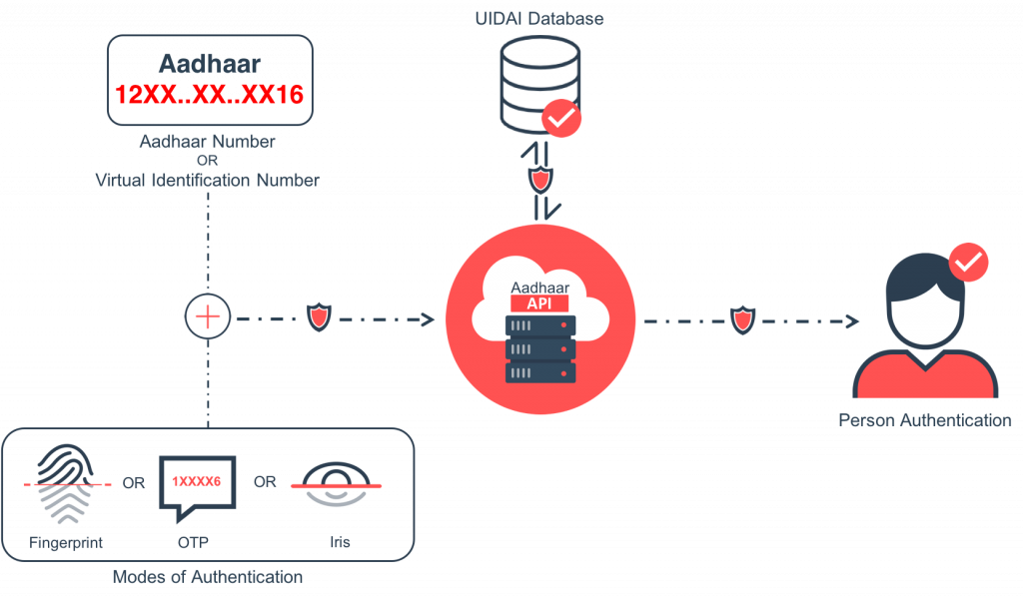

**Verifying Bank Account using API**

An absolute proof provided by seller by entering his/her Bank Account Number and IFSC Code of the Bank. The response returns the Name of the bank account holder validating the individual instantly.

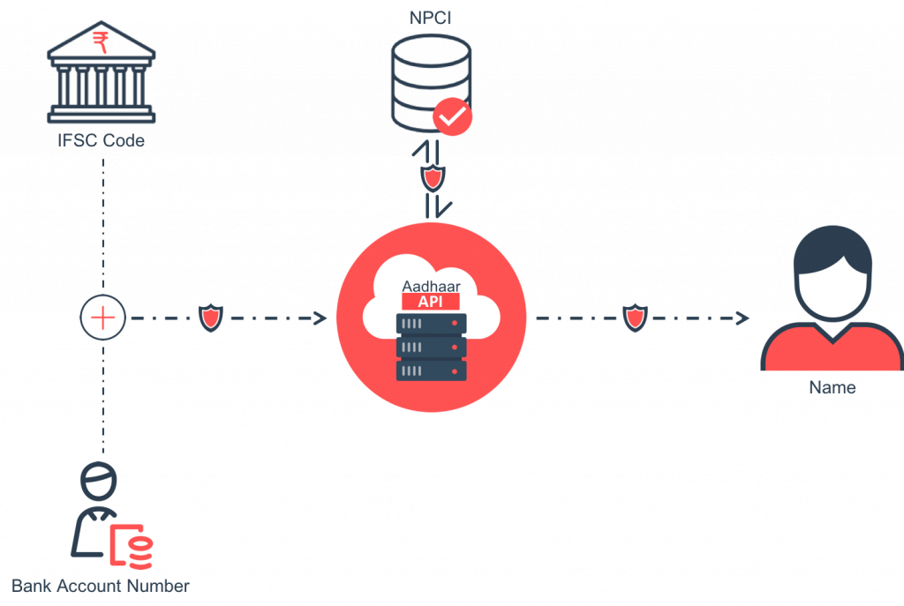

A secure database will be required to store the sensitive data of the sellers.

**USE OF A WEB APPLICATION FIREWALL (WAF)**

Many people are under the misconception that protecting the web server has nothing to do with the database. This is not true. In addition to protecting a site against cross-site scripting vulnerabilities and website vandalism, a good application firewall can prevent SQL injection attacks as well. By preventing the injection of SQL queries by an attacker, the firewall can help keep sensitive information stored in the database away from attackers.

**PROJECT OVERVIEW**

Through this website sellers or company can register by accepting our terms and conditions where seller have to give the required details according to our policy, so that we can create a profile that relates the seller or the company for future investigation. The company or seller get verified only if they meet the demand required by our policy.

Once the seller or company get verified, we will provide an identity of true seller to them and they won’t be able to scam or sell their product illegally on any social media sites. We will also accept customer reports if they’ve been scammed by any of the seller or company, so that we can take further steps and aware other customers about that fraud seller. We will also provide rating according to the services of a company so that the customer can make a hassle free and confidential purchase.

This project focuses on idea of building trust of the customers on the online sellers or companies.

In order to prevent the customers or users from online fraud and scam.

Ratings of the sellers will let the customers know that which seller is best according to the product or service they provide.

**RESULTS**

According to our analysis, in order to prevent the customers or users from online fraud and scam, the project will help in building the trust of the customers so that the customer can make a hassle free and confidential purchase on social media sites.

For a unverified seller, the customer can make a report to us about the incident of scam so that we can try to look for the issue and also aware the other customers about that seller.

Open ratings can be elected by the customers to the sellers according to the services they provide.

It will help other users or customers by preventing them from unwanted scams.

**CONCLUSIONS**

This project will merely help people from all kind of online scams from the product selling users. Our results do support the criteria but it can be more advantageous if there will be proper analysis of feedback provided by the customers.

I think the project works well according to the system and had no problems, except for the fact that we are not able to make the database that much secure so that we can store sensitive data like the identity proofs provided by the sellers which would be a big risk.

An interesting future study might involve betterment of the project on security based conditions.

**REFERENCES**

* *Verify the identity of the residents with two factor authentication i.e. Aadhaar number <* [*https://aadhaarapi.com/*](https://aadhaarapi.com/)*>*
* *API AUTOMATION:  
  Conduct and collaborate with a complete API-driven automation that requires no manual intervention <* [*https://aadhaarapi.com/*](https://aadhaarapi.com/)*>*
* *Best Practice to secure a database:*

*<* [*http://www.dbta.com/Editorial/News-Flashes/5-Best-Practices-for-Securing-Databases-101930.aspx*](http://www.dbta.com/Editorial/News-Flashes/5-Best-Practices-for-Securing-Databases-101930.aspx) *>*

* *The idea of providing ratings to a company followed by*

*<* [*https://www.crisil.com/en/home/our-businesses/ratings/credit-ratings-list.html*](https://www.crisil.com/en/home/our-businesses/ratings/credit-ratings-list.html) *>*

* *Only legal site in India to report online scams to report a crime related complaint using this central Digital Police Portal:*

*<* [*https://digitalpolice.gov.in/ncr/State_Selection.aspx*](https://digitalpolice.gov.in/ncr/State_Selection.aspx) *>*